UI/UX

Domain: Real Estate (INDIVIDUAL PLAYERS)
(self analysis)

Sites: DLF, Lodha, Godrej Properties, Niyati

Name: ASHIT SINHA
PRN: 1262242973
Roll No: 22
Panel: F
Batch : F1

DLF
Parameter | Score | Observation
Learnability | 9 | The homepage is easy to understand and the main project sections are visible without much problem.
Usability | 9 | Project details, location and enquiry options are easy to use. Some pages have a lot of information together.
Consistency | 9 | DLF keeps its branding, fonts, buttons and image style fairly consistent.
Use of Metaphors | 8 | Search, location, menu, call and enquiry icons are familiar and easy to understand.
Navigation Structure | 8 | Navigation is clear but because there are many projects and locations, finding one exact project can take time.
Visual Hierarchy | 9 | Large project images and featured projects grab attention and important CTAs are visible.
Accessibility | 7 | Text is mostly readable but accessibility options could be easier to find.
Responsiveness | 9 | The layout adjusts well on different screen sizes and the main content remains usable.
Efficiency of Interaction | 8 | Users can reach project information and enquiry forms in a few steps.
Feedback & System Status | 8 | Buttons and forms give reasonable feedback, but some states could be clearer.
Error Prevention & Recovery | 8 | Forms are straightforward, but clearer messages for incomplete information would help.
Aesthetic & Minimalist Design | 9 | The website has a premium and spacious look and does not feel very crowded.
Content Readability | 9 | Headings and project information are easy to scan with good use of images.
Search & Discoverability | 8 | Project and location discovery is good, but a compare feature would make it better.
Performance Perception | 8 | The site feels professional and generally smooth, although image-heavy pages can take more time.
Trust & Credibility | 10 | DLF is a well-known developer and the website gives a strong established-brand impression.
Personalization | 8 | Location and project relevance help users, but there is not much deeper personalization.
User Satisfaction | 9 | Overall it gives a trustworthy and premium experience for a person seriously looking to buy a home.
Overall impression: 8.5/10
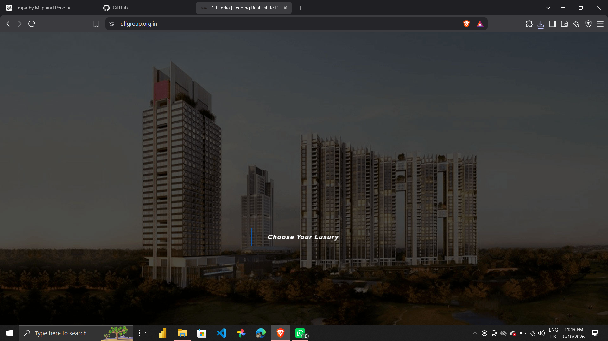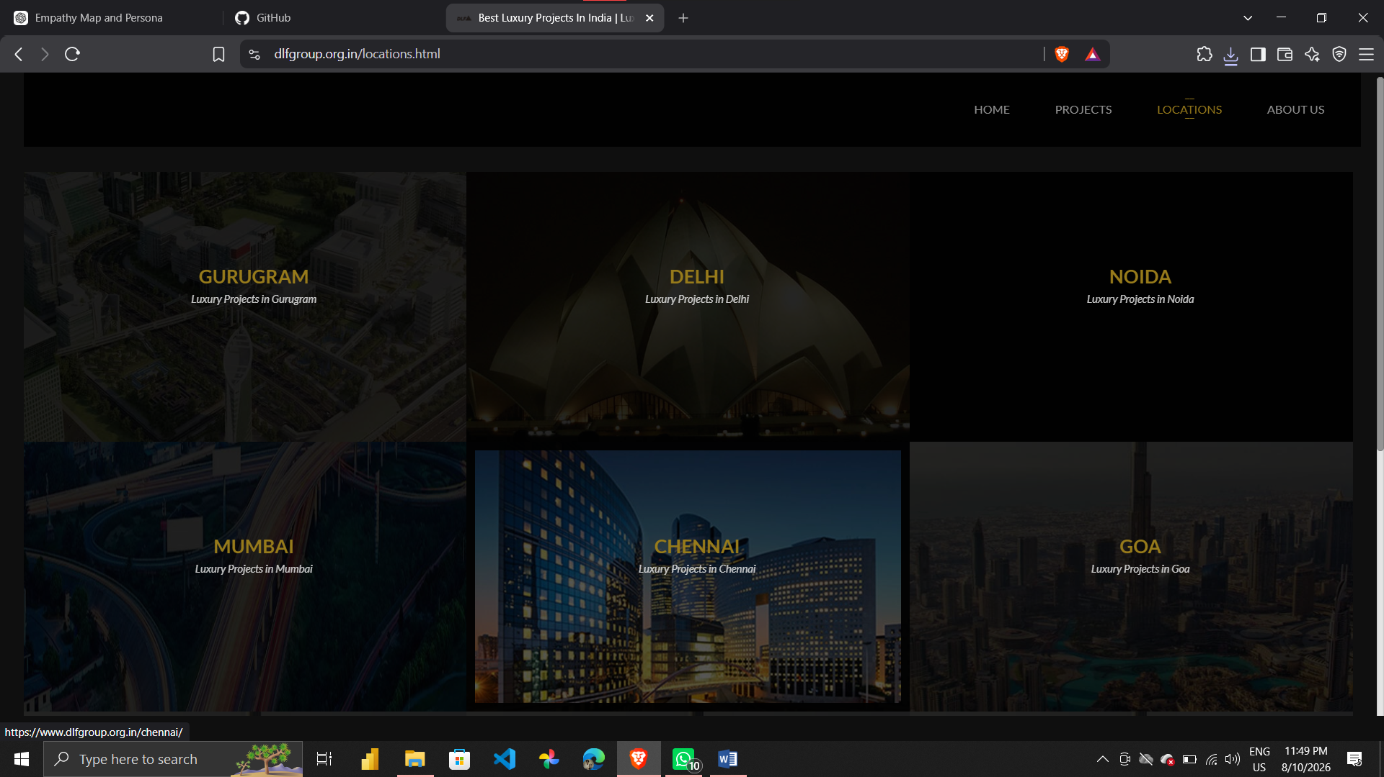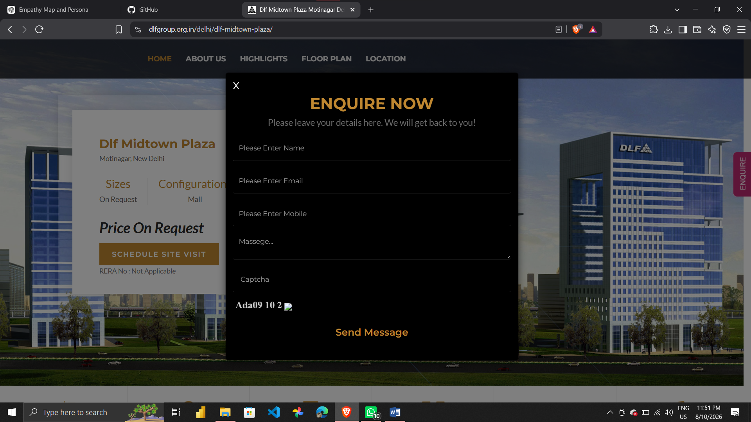
Lodha
Parameter | Score | Observation
Learnability | 8 | The interface is understandable but premium visuals and promotional sections can take attention away from basic information.
Usability | 8 | Project browsing and enquiry actions are simple. Some detailed pages need more scrolling.
Consistency | 9 | The luxury style, colours, typography and photography are used consistently.
Use of Metaphors | 8 | Common icons and real-estate symbols are used for search, location, contact and enquiry.
Navigation Structure | 8 | Projects and locations are easy to reach, but the number of sections can make the journey slightly long.
Visual Hierarchy | 9 | High-quality property images and large headings make featured projects stand out strongly.
Accessibility | 7 | The content is readable but accessibility information and controls are not very prominent.
Responsiveness | 9 | The website maintains its visual structure well across desktop and smaller screens.
Efficiency of Interaction | 8 | Main actions are easy, but users have to explore several sections before getting all project details.
Feedback & System Status | 8 | Forms and buttons respond normally, though more visible confirmation messages would help.
Error Prevention & Recovery | 8 | Basic form handling is clear, but recovery guidance could be more direct.
Aesthetic & Minimalist Design | 9 | Very polished and premium looking. The visual style matches the brand.
Content Readability | 9 | Large headings and short content blocks make important information easy to notice.
Search & Discoverability | 8 | Project discovery is good, but comparing two or more projects is not very direct.
Performance Perception | 8 | The site feels smooth overall, but large images can make some pages feel heavy.
Trust & Credibility | 10 | Strong brand presence and detailed project presentation create high trust.
Personalization | 8 | Location and project choices are relevant, but the website could remember more preferences.
User Satisfaction | 9 | The overall experience feels premium and is good for users who care about presentation and brand image.
Overall impression: 8.4/10
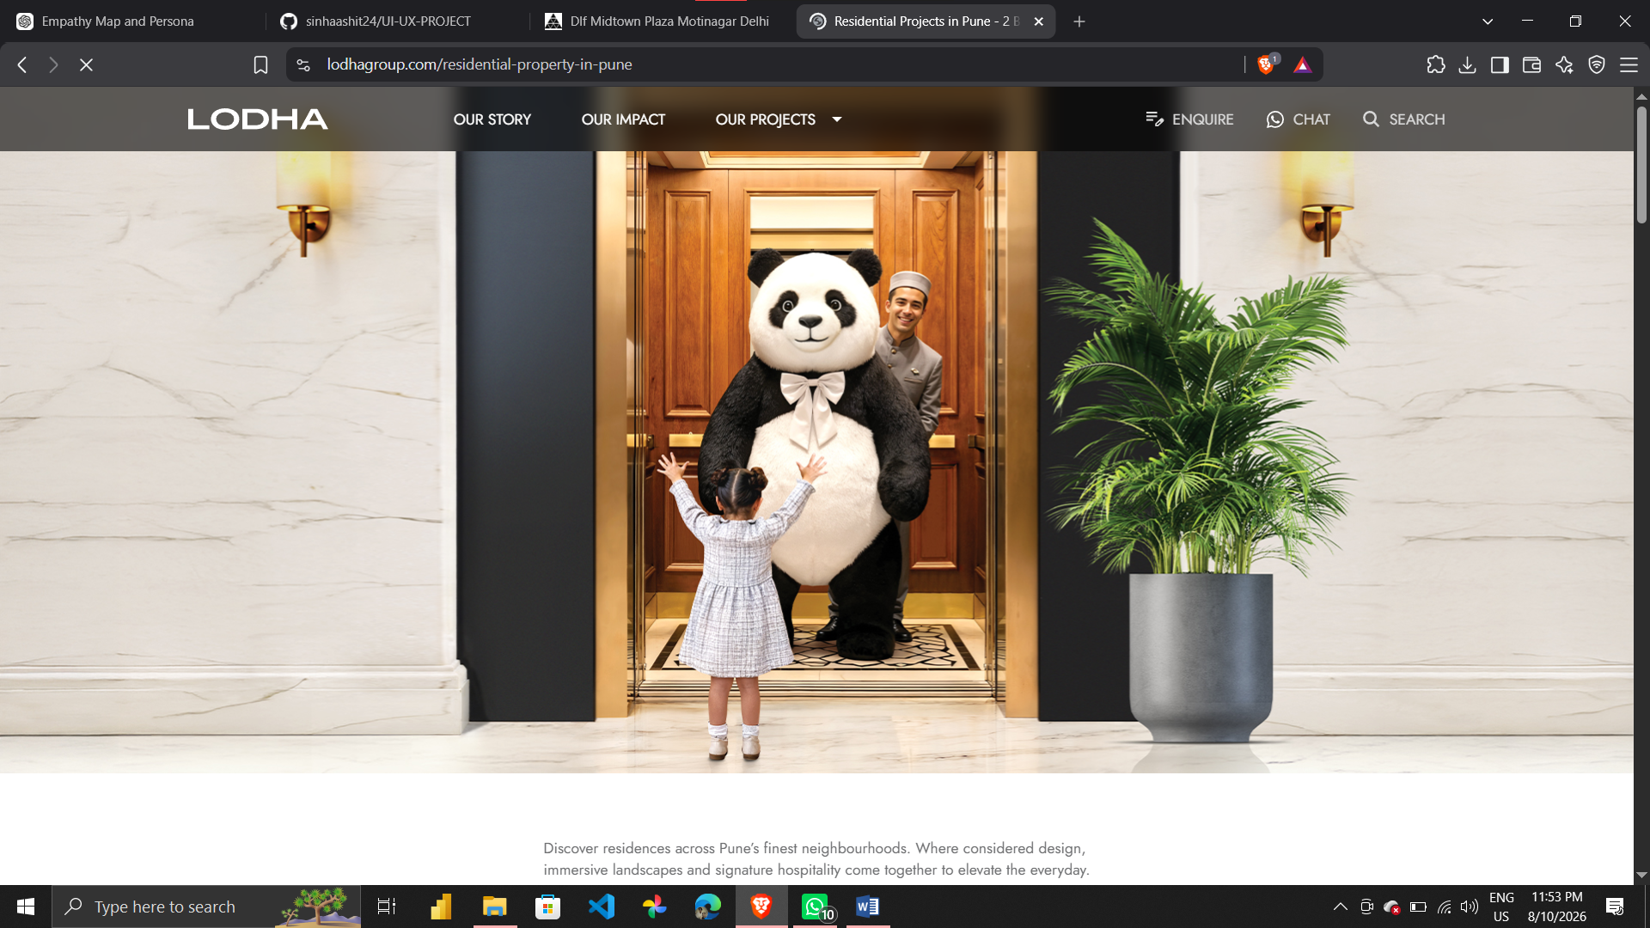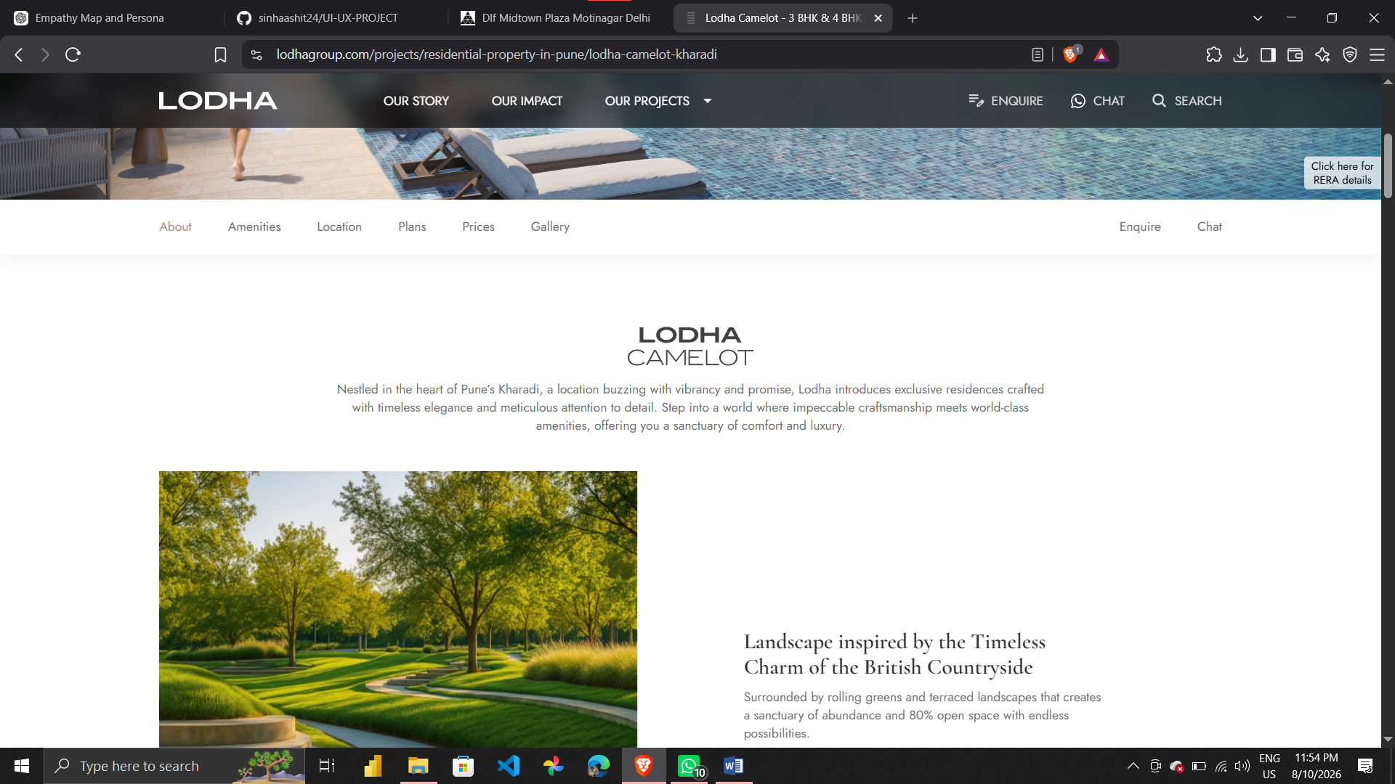

Godrej Properties
Parameter | Score | Observation
Learnability | 9 | The main sections are easy to understand and project information is organised clearly.
Usability | 9 | Browsing projects, checking details and sending an enquiry are simple and direct.
Consistency | 9 | Brand colours, cards, buttons and typography are used consistently.
Use of Metaphors | 9 | Familiar search, location, filter, contact and property icons make the interface easy to understand.
Navigation Structure | 9 | The project and location structure is clear and users can move between sections without much confusion.
Visual Hierarchy | 9 | Project cards, locations, images and enquiry buttons get good visual importance.
Accessibility | 8 | Text and buttons are generally readable, although stronger accessibility controls would improve it.
Responsiveness | 9 | The website works well across common desktop and mobile layouts.
Efficiency of Interaction | 9 | A user can reach project details and enquiry actions without too many unnecessary steps.
Feedback & System Status | 9 | Forms and interactive elements give fairly clear feedback.
Error Prevention & Recovery | 9 | Structured forms and clear fields reduce the chance of mistakes.
Aesthetic & Minimalist Design | 9 | Clean and professional without overloading every section with promotional content.
Content Readability | 9 | Project details are broken into understandable sections with good headings and visuals.
Search & Discoverability | 9 | Finding projects by location and requirements is comparatively easy.
Performance Perception | 9 | The website feels stable and professional while moving through project pages.
Trust & Credibility | 10 | Godrej's established brand and project information make the site feel reliable.
Personalization | 9 | Project and location relevance is useful for narrowing down choices.
User Satisfaction | 9 | It provides a balanced experience between information, visuals and easy navigation.
Overall impression: 9.0/10
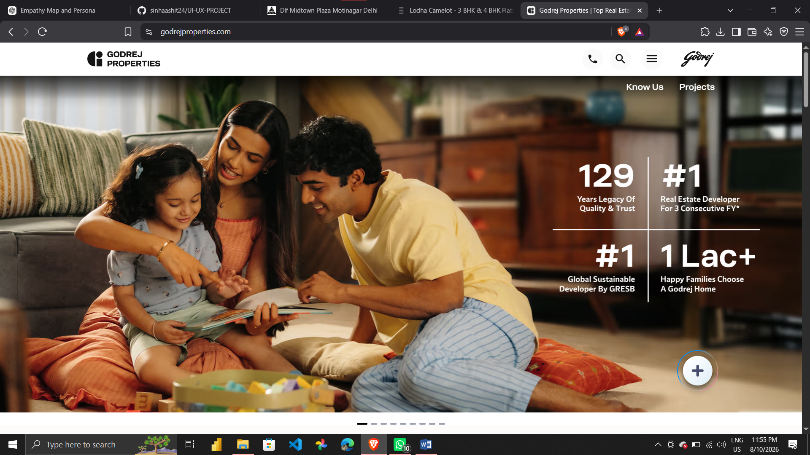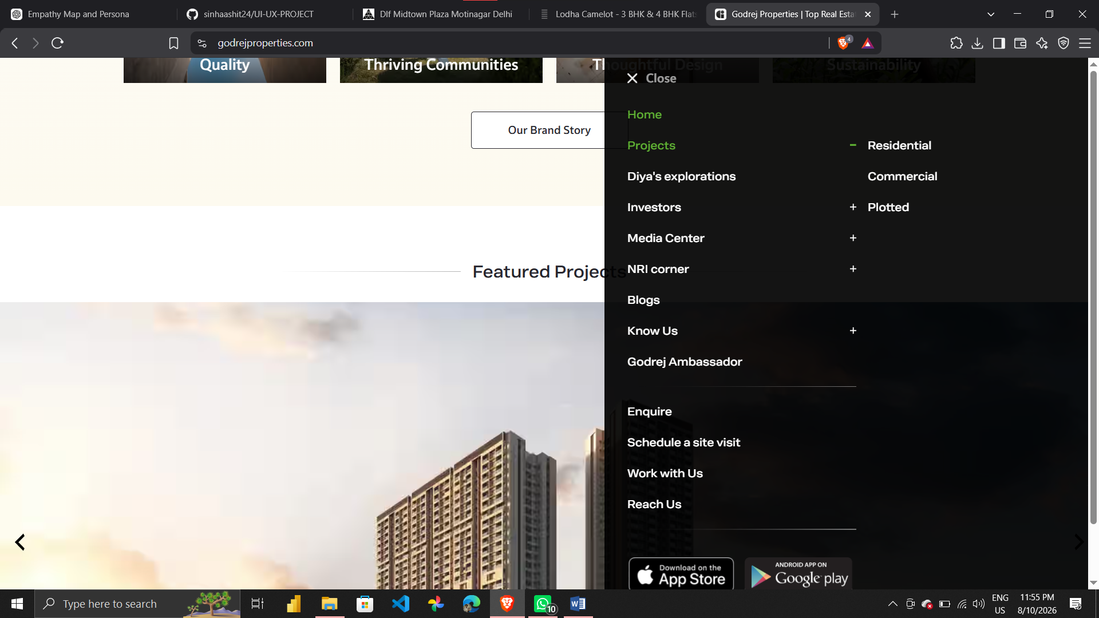
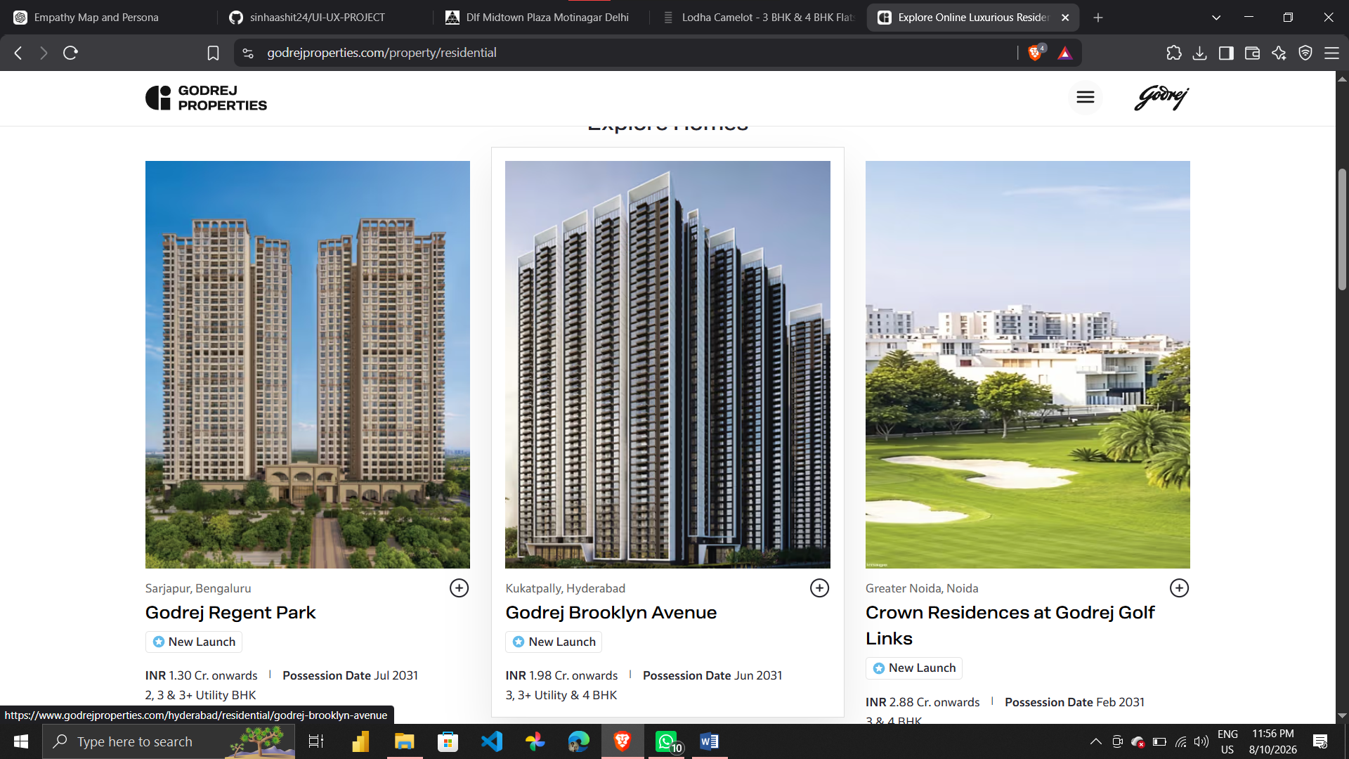
Niyati
Parameter | Score | Observation
Learnability | 7 | The website is not difficult to understand, but some information does not feel as structured as the larger developer sites.
Usability | 7 | Basic project and enquiry actions work, but some journeys need extra effort.
Consistency | 7 | Branding is visible but the layout and content blocks are not always as consistent as the bigger sites.
Use of Metaphors | 7 | Normal property, contact and navigation icons are familiar to users.
Navigation Structure | 6 | Navigation is simple, but there are fewer filters and discovery options for comparing projects.
Visual Hierarchy | 7 | Important project information is visible, but stronger headings and sectioning would improve focus.
Accessibility | 6 | Text is generally readable, but there are fewer visible accessibility features.
Responsiveness | 7 | The main layout works on common screens but could be refined further for smaller devices.
Efficiency of Interaction | 7 | Users can reach enquiry information, although checking and comparing details needs more manual effort.
Feedback & System Status | 6 | Basic feedback is present, but form confirmations and other states could be clearer.
Error Prevention & Recovery | 6 | Error handling is fairly basic and could give more useful guidance.
Aesthetic & Minimalist Design | 7 | The design is functional and clean, but it does not feel as polished as the bigger competitors.
Content Readability | 7 | The information is understandable, though some sections could be more scannable.
Search & Discoverability | 6 | Search and filtering are less powerful, so users may need to browse manually.
Performance Perception | 7 | The site gives an acceptable performance impression, but the experience could feel more optimized.
Trust & Credibility | 8 | The developer has credibility, but more visible trust signals would help first-time buyers.
Personalization | 6 | There is limited personalization beyond basic project or location relevance.
User Satisfaction | 7 | Good for basic project research, but stronger information structure and discovery would make it better.
Overall impression: 6.7/10
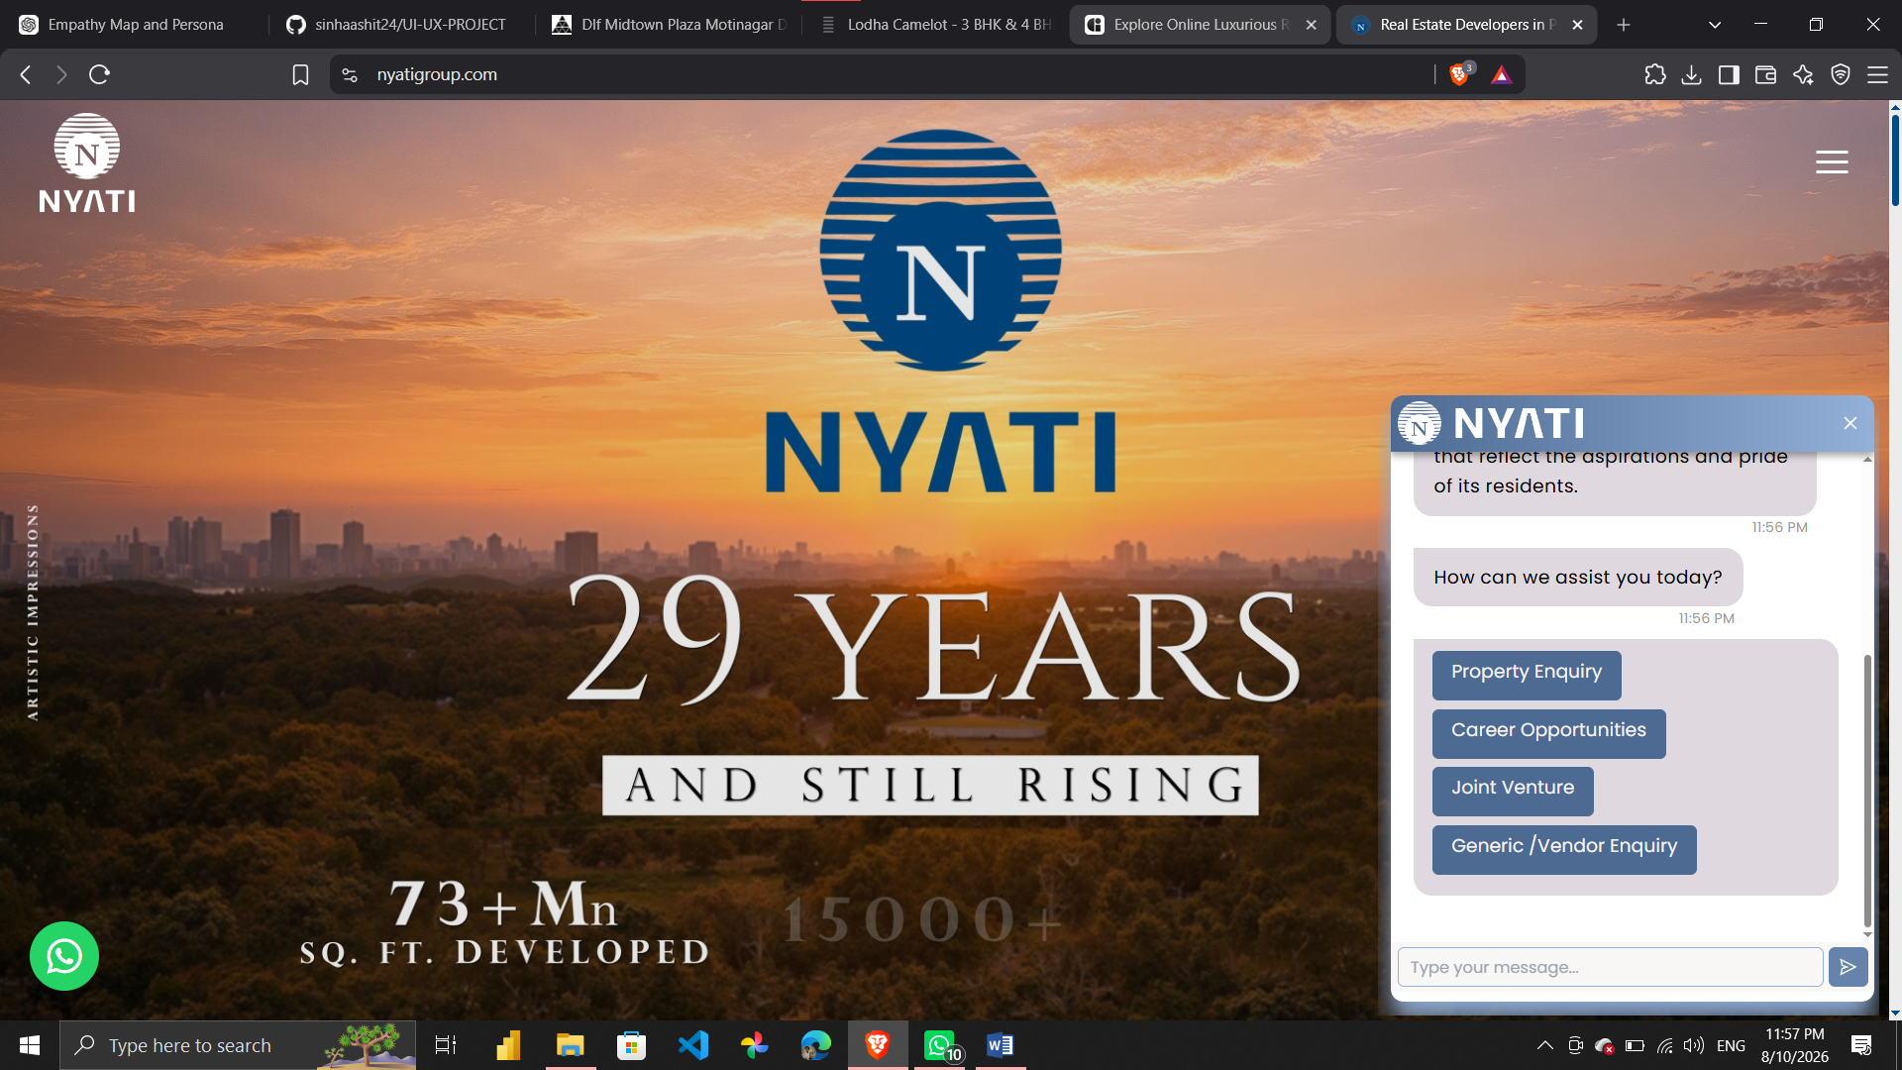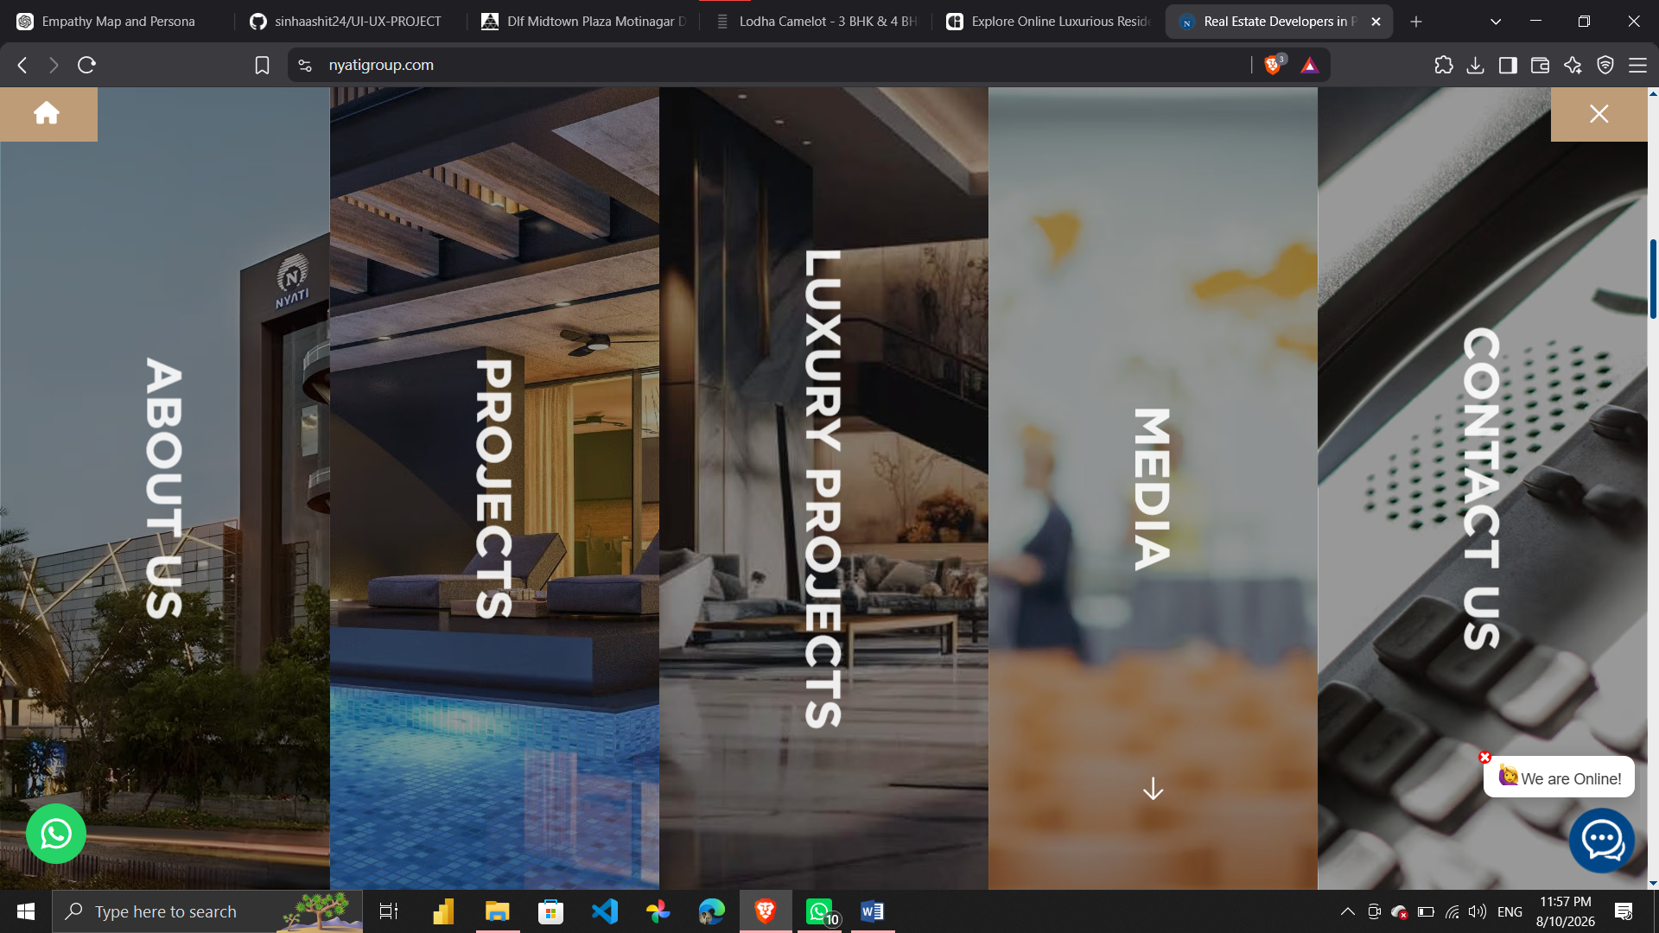
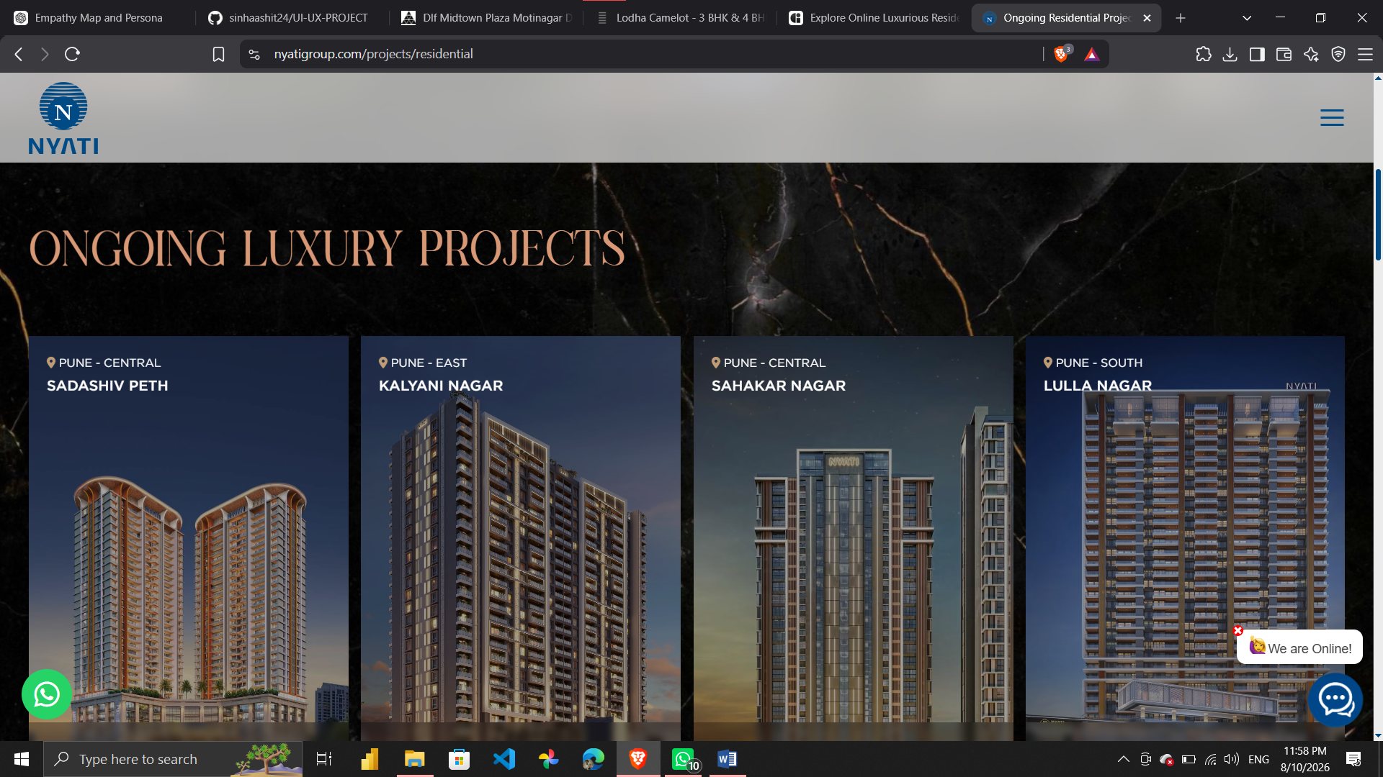

FINAL COMPARISON
After analysing the four websites, Godrej Properties has the most balanced UI/UX overall.
• DLF and Lodha are stronger in visual presentation and brand trust, while Niyati has more scope for improvement in navigation and discoverability.
• DLF – strong brand trust, clean premium look and good project presentation.
• Lodha – very strong visual design and premium feel.
• Godrej Properties – balanced navigation, information and usability.
• Niyati – simple and functional, but needs better structure and discovery.
• Main improvement for all four: make project comparison, pricing transparency, filters, RERA/trust information and site-visit booking easier to find.

